Word and Word Styles Guide
A brief look at getting the best out of Word and Word Styles.
Instructions can vary slightly in different versions of Word.

Contents
What are Word Styles and How Do I Use Them? 3
A level 2 heading. 3
A level 3 heading. 3
Inserting and Configuring Figures 5
Inserting and Configuring Tables 6
Production Workflow 7
Setting up your workspace 8
Setting up styles 13
Style Sets 15

What are Word Styles and How Do I Use Them?
In Word, different paragraphs can have their visual presentation styled in particular ways. Different styles are set up for different elements in the report.
Styles are controlled using the “styles” panel in the top right (you may need to extend the ribbon to see this).
Turning on the styles panel
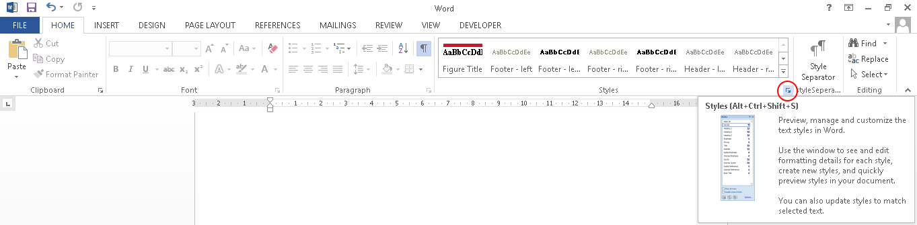
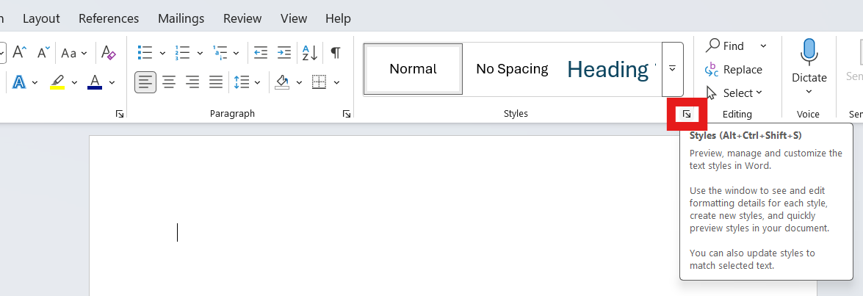
There are four supported heading levels. You can see a level 1 heading at the top of this page. The other three heading levels look like this:

A level 2 heading.

A level 3 heading.

A level 4 heading (lowest level heading)
These headings show in the navigation pane on the left. Note that you should not “jump” heading levels e.g. Heading level 1 followed by Heading level 3.
Turning on the navigation pane: View > Navigation Pane Show
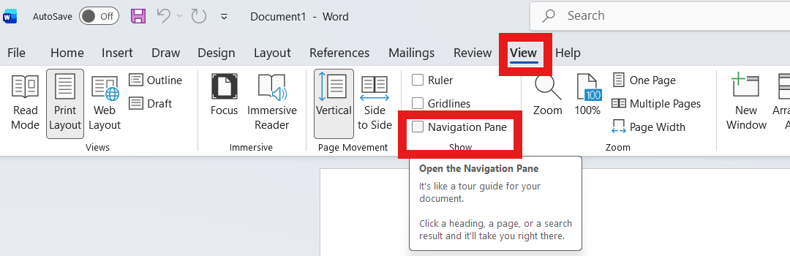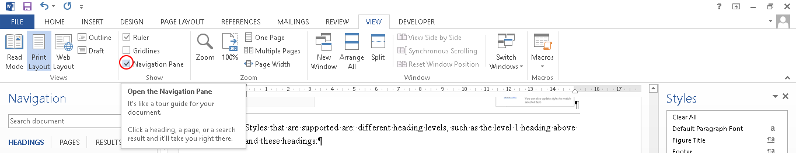

The navigation pane is called “Document Map” in earlier versions of Word.
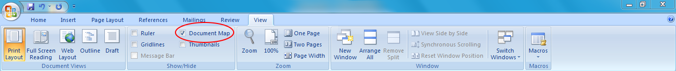

- You can have Bullets in the “list paragraph” style.
  - Second level bullets are in the “summary” style.

You can also have quotes in the “quote” style

Some direct formatting is supported to apply bold, italics, superscript, subscript and so on. Footnotes can also be used in the usual way using the Word Insert Footnote feature.
If you use restricted editing in your document, direct formatting isn’t available in Word, but you can set up character styles for bold, italic etc.
With the current exception of the “Table Header” style, all styles in a Word document can be mapped to the supported styles on your Content Catalyst site. For Example if you use the word style “Caption” for your figure or table titles, you do not need to rename this in the Word document, simply map the “Caption” style to “Exhibit Title” style on-site.

Inserting and Configuring Figures
Here is an example figure. You can copy and paste this example to use it elsewhere. The figure must be inserted as an image, chart objects, smart art etc. are currently not supported.

The title of the figure in the “Figure Title” or “Exhibit Title” style
and this must be a single paragraph, but shift+enter can be used to enter new lines
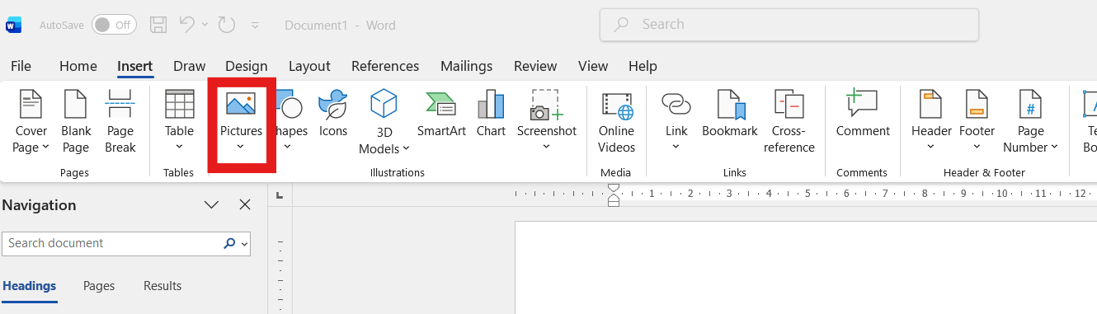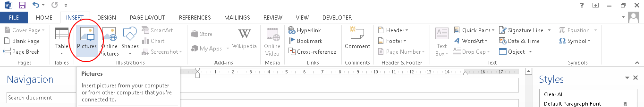
An optional note in the notes style. This must be a single paragraph, but shift+enter
can be used to enter new lines. Notes must be followed by a source.
The source of the figure in the “source” style

Inserting and Configuring Tables
Here is an example table. You can copy and paste it to use it elsewhere. The table title is a separate paragraph above the table, similar to the “Figure Title” style.
Cell alignment is honored. Table headers should be in the “Table Header” style. Note that this is the only style that can’t currently be mapped.
The title of the table in the “Table Title” style
it must be a single paragraph, but shift+enter can be used to enter new lines
Heading | heading |  | heading
Heading | heading | heading | heading | heading
Data | data | data | data | data
Data | data | data | data | data
Data | data | data | data | data
An optional note in the notes style. This must be a single paragraph, but shift+enter
can be used to enter new lines. Notes must be followed by a source.
The source of the figure in the “source” style

Long tables will split over multiple pages automatically – you do not want to manually split tables. To repeat the heading rows, you must select the rows you want to repeat (this must include the top row) and select “repeat header row” as illustrated here:
Turning on repeated headers. > Table Layout > Data > Repeat Header Rows
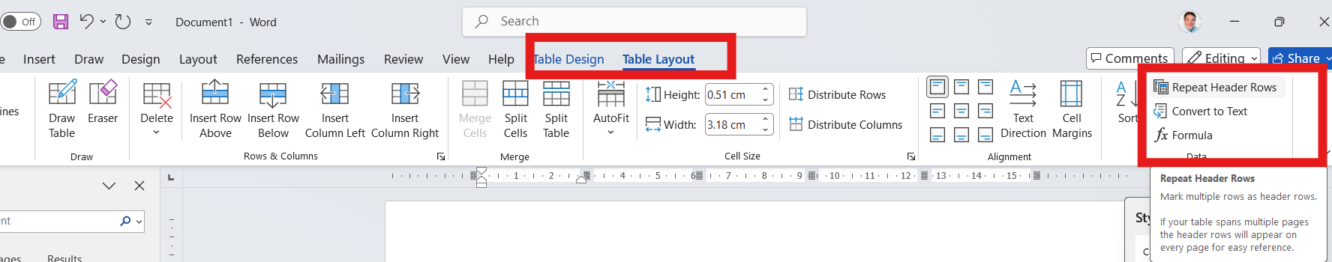

Production Workflow
If you use tracked changes, you can continue to use this in the normal way, but the document must be finalized and changes accepted before putting through convert.
You will notice that if you use a restricted document, the direct editing features are greyed out in Word, and you might be used to highlighting text using the highlight tool. The best way to highlight text is to use Word comments, as illustrated here:
Inserting a comment in Word > Review > New Comment
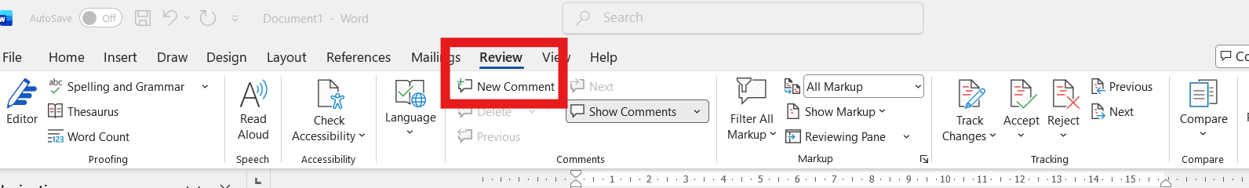
How these highlighted areas appear depends on the tracking options you have selected.

Setting up your workspace
This section of the guide shows you how to use and setup word and word styles

The following are suggestions for setting up your workspace:

- Show the navigation pane:
  - View -> show -> navigation pane

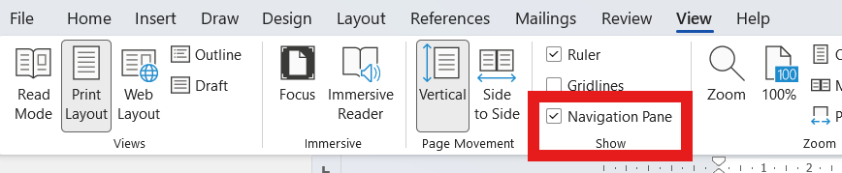

- Show the styles window:
  - Home -> styles -> styles window popup

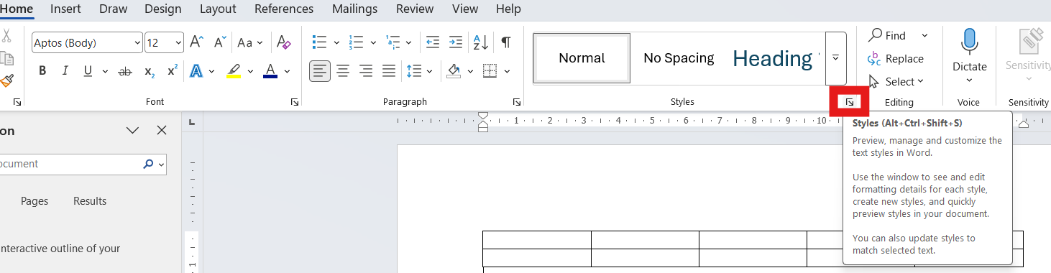

If you want to use draft view (this is not necessary, but is sometimes useful):

- In Microsoft Word, set View to Draft and choose the Show Formatting Marks option. (Look for this symbol: ¶)

  - Note: it is a “feature” of Word 2007 and Word 2010 that you cannot see images in docx files when viewing in draft mode. You can still see images if you are using a doc however.

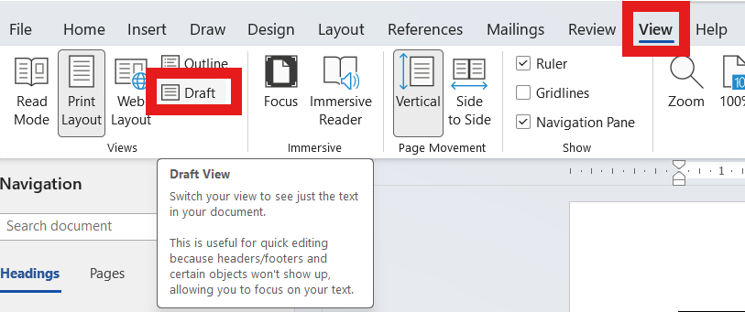

- Set draft mode to ignore print margins and to wrap in window:
  - Options -> advanced -> show document content -> show text wrapped within document window

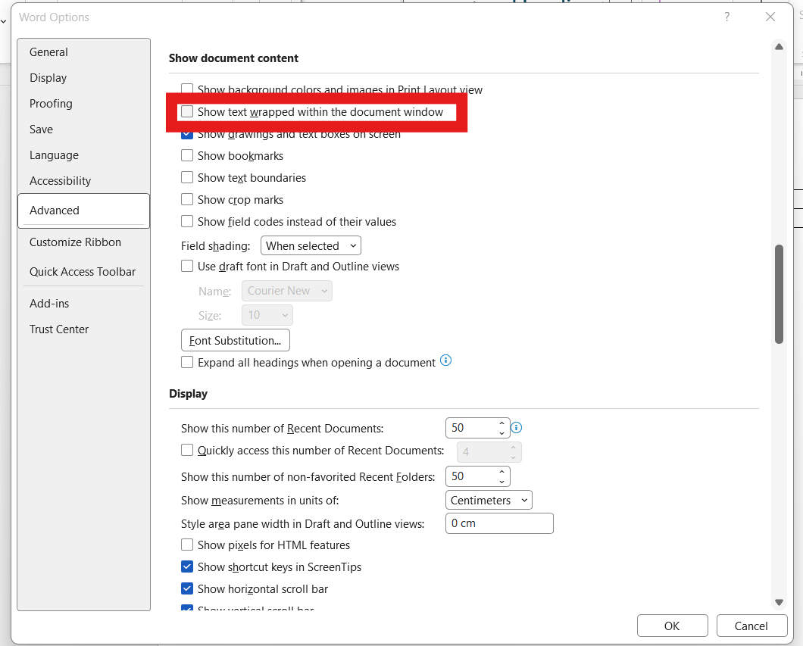

- Show the style area pane
  - Options -> advanced -> display -> style area pane -> set value that works with your monitor (2cm say)

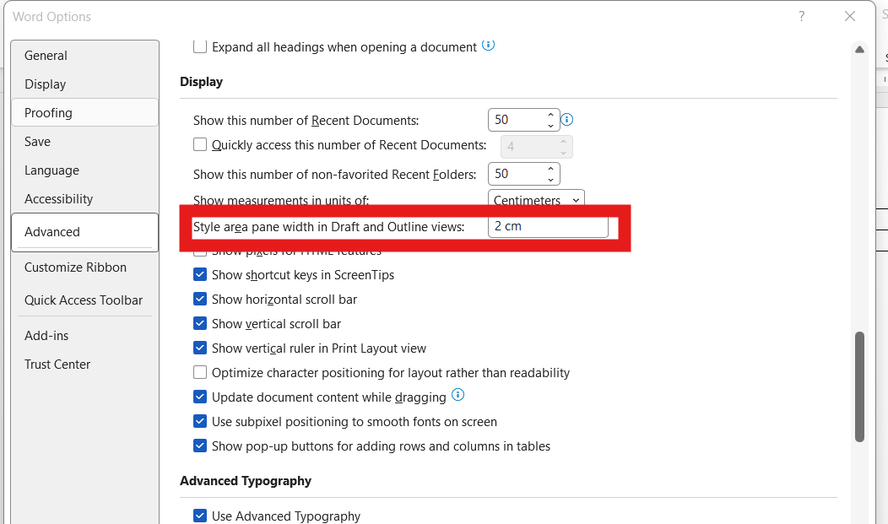

Draft mode with these settings looks something like the screenshot below, where the styles are shown in the style area pane.

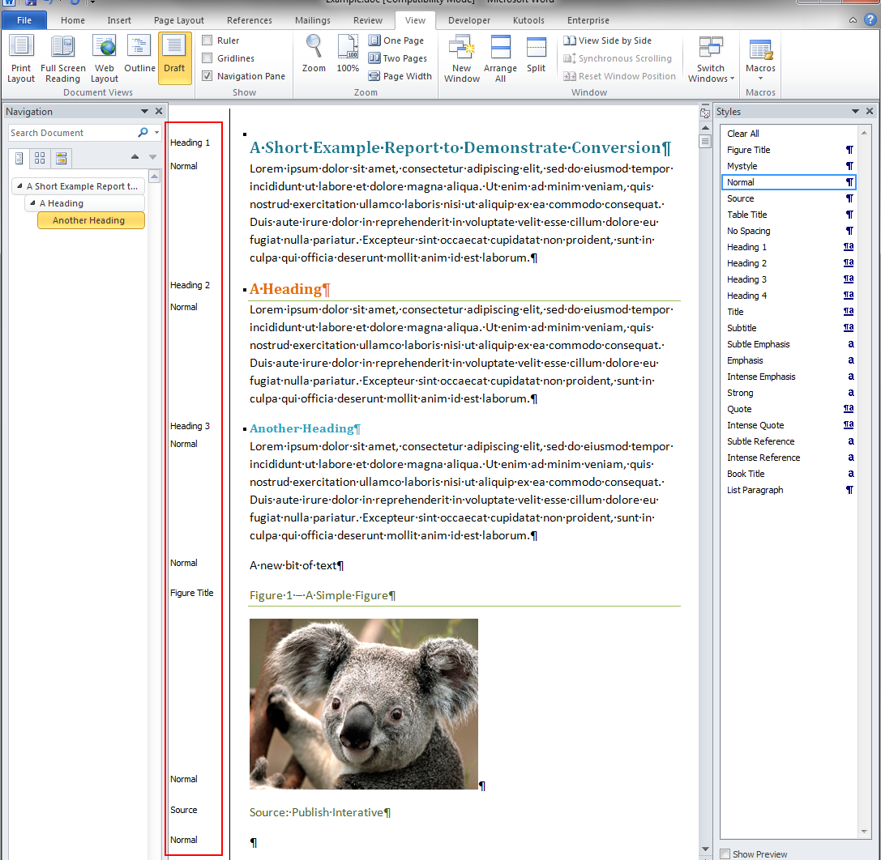
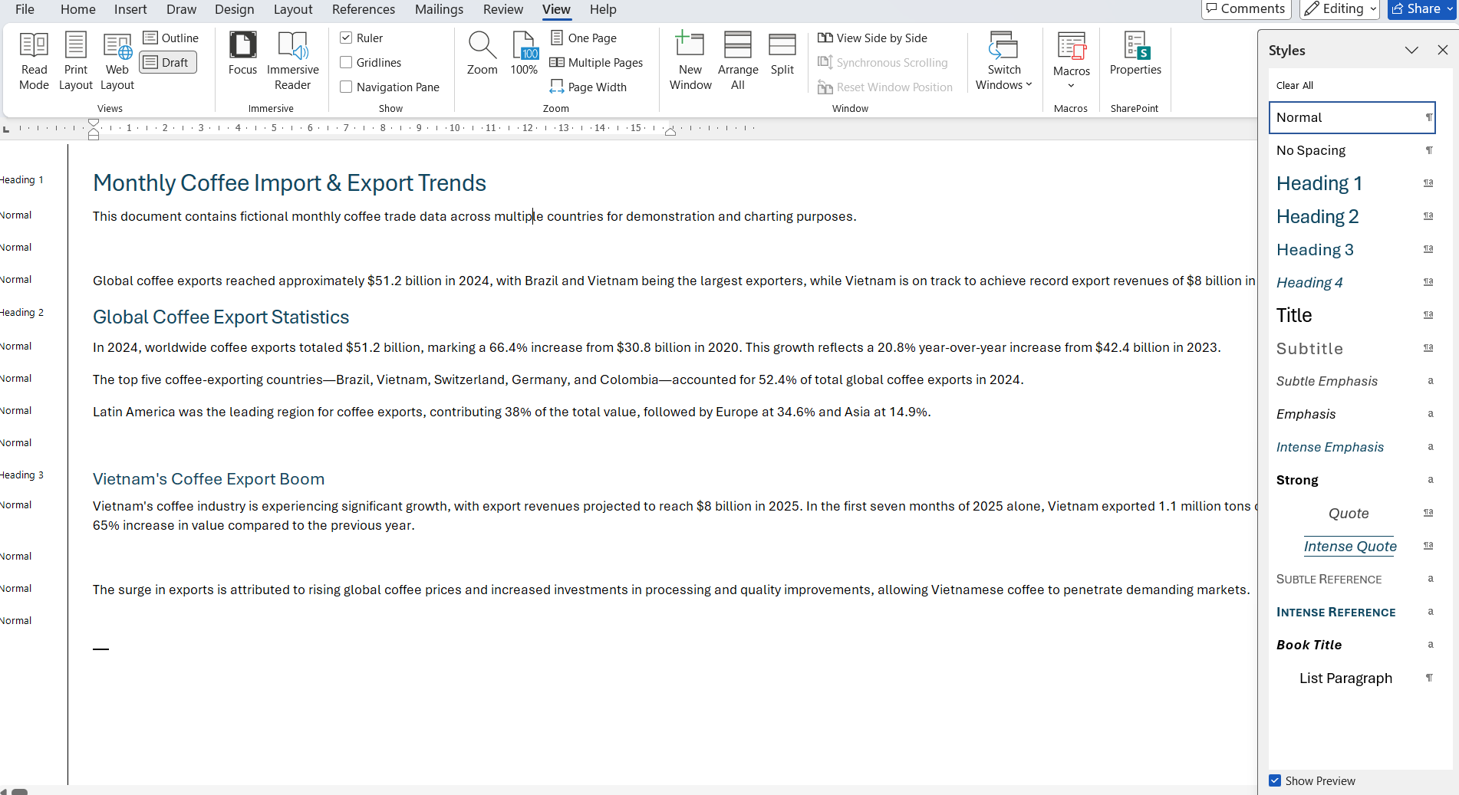

Setting up styles
If you want to set up more styles (say you don’t have the “Figure Title” style):

- Show the styles window:
  - Home -> styles -> New Style

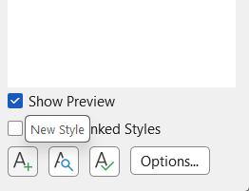

Type in a name and click “new”
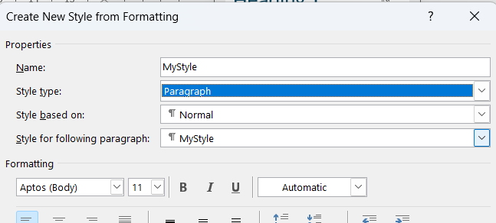
To edit an existing style select from the style menu and use the dropdown arrow to select modify.
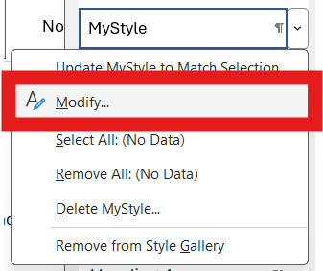
In the modify window you can change the font, colour, border etc.

Style Sets
Groups of styles can be saved as style sets. Saving a style set saves all the styles that are available in that document:

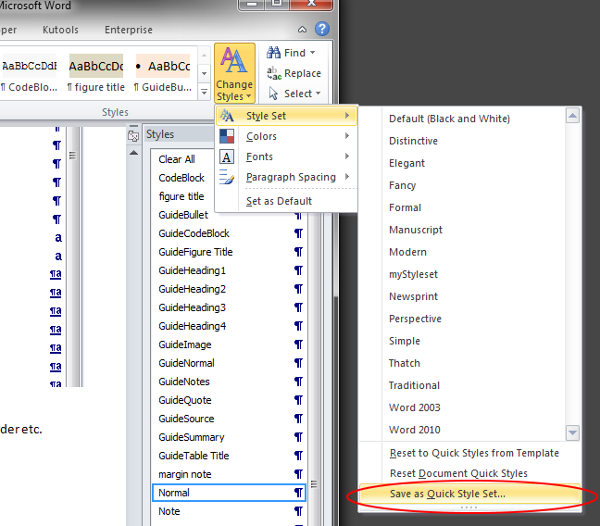

You can then give your style set a name:

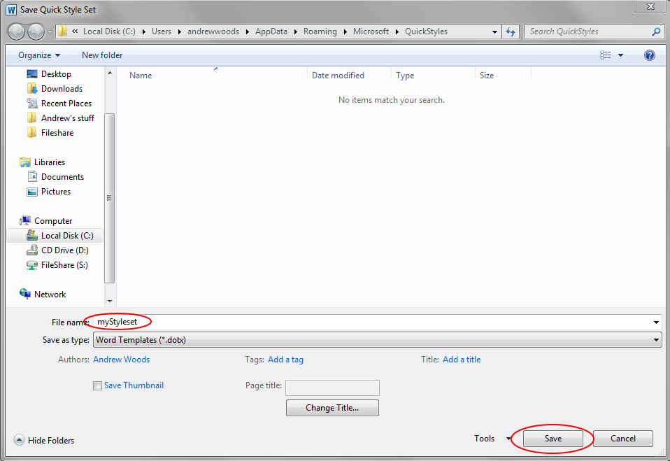

You can load a style set to make those styles available in your document:

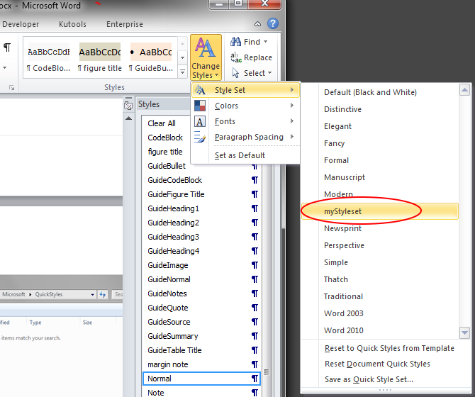

As shown here.
Chart objects may work to a certain extent, but are not fully supported

